Master Processor PROM in
PT5210 Varitime TM Digital Sync Generator

Supplement to: PT 5210 Reference: Manual no. 9499 491 02211
The master processor PROM in the PT 5210 VariTime™ Digital Sync Generator can be installed by technical qualified users.
Exchange of the master processor PROM is typically only required for configuration of some special versions or for update of the master software version.
The version of the master software can be identified during power op of the PT 5210 VariTime Digital Sync generator. Immediately after the self-test the display shows “Version: xx.x-yy.y”, where xx.x indicates the master processor software version and the yy.y indicates the internal sync pulse generator software version.

- Open the PT 5210 by removing the top cover.
- Identify the master processor PROM on the processor module mounted flat behind the display module. See Picture 1
- By use of suitable IC extractor remove the master processor PROM.
- Insert the new processor PROM. Take care to orientate the PROM correctly.
- Insert diode in fan circuit according to drawing.
- Mount the top cover on the PT 5210.
- Perform a factory reset: While pressing the two buttons ARROW RIGHT and ARROW LEFT simultaneously turn on the power.
- Observe that the display reflects the changes included with the master processor change.

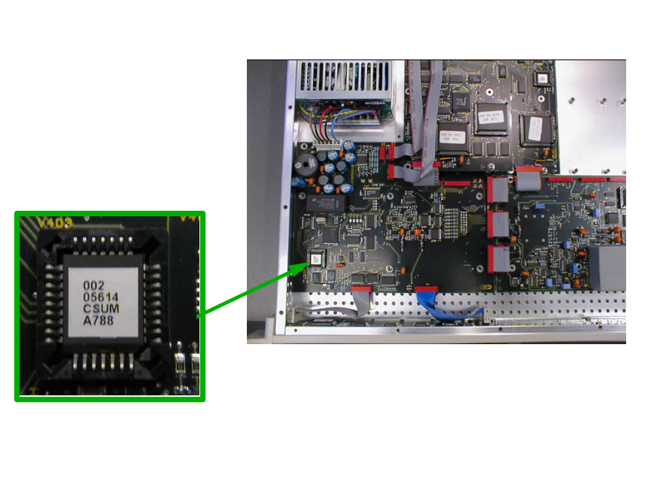
Picture 1: The positioning of the master processor PROM. The lower right corner on the PROM is indicated by a cut in the chip. (Note, that code number on actual PROM may differ from Photo)
Present number is 4008 002 07221; checksum EE52

Modification of the drive to the fan:
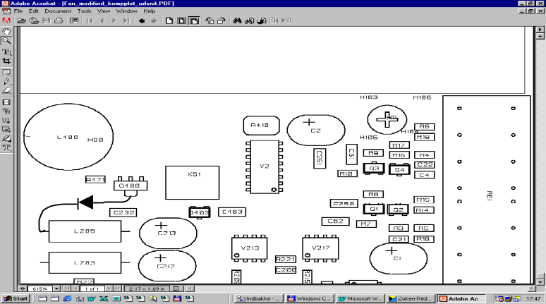For older series of the PT5210 a BAV20 diode has to be inserted according to drawings below:
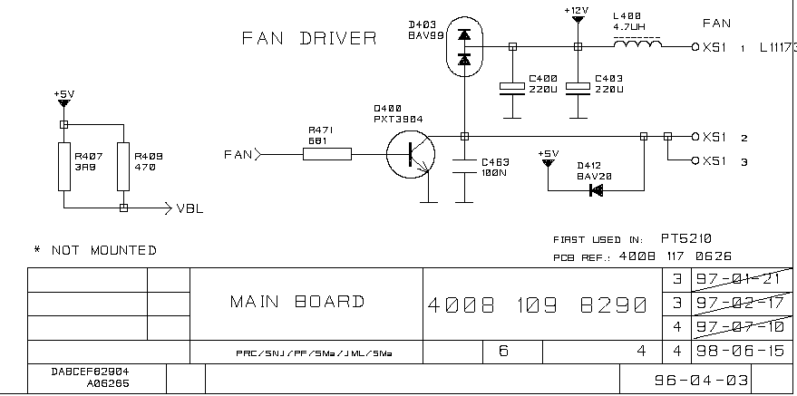
Add BAV20 or BYV95
BAV20 or alternative, i.e BYV95
Mounted between L205 and D403

